* Task 1: Create and assign tags via the Azure portal
* Task 2: Enforce tagging via an Azure policy
* Task 3: Apply tagging via an Azure policy

Task 1: Assign tags via the Azure portal

In the Azure portal, start a **PowerShell** session within the **Cloud Shell**.Run df

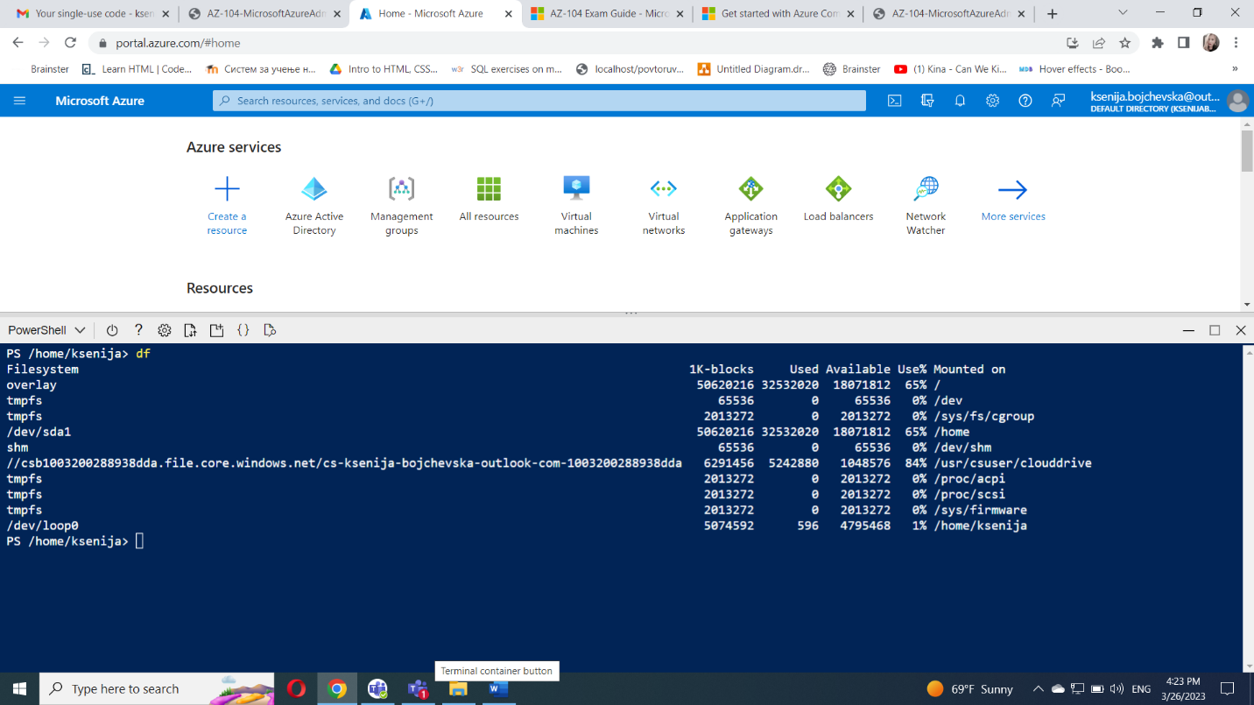

In the Azure portal, search and select **Storage accounts** and, in the list of the storage accounts, click the entry representing the storage account you identified in the previous step.

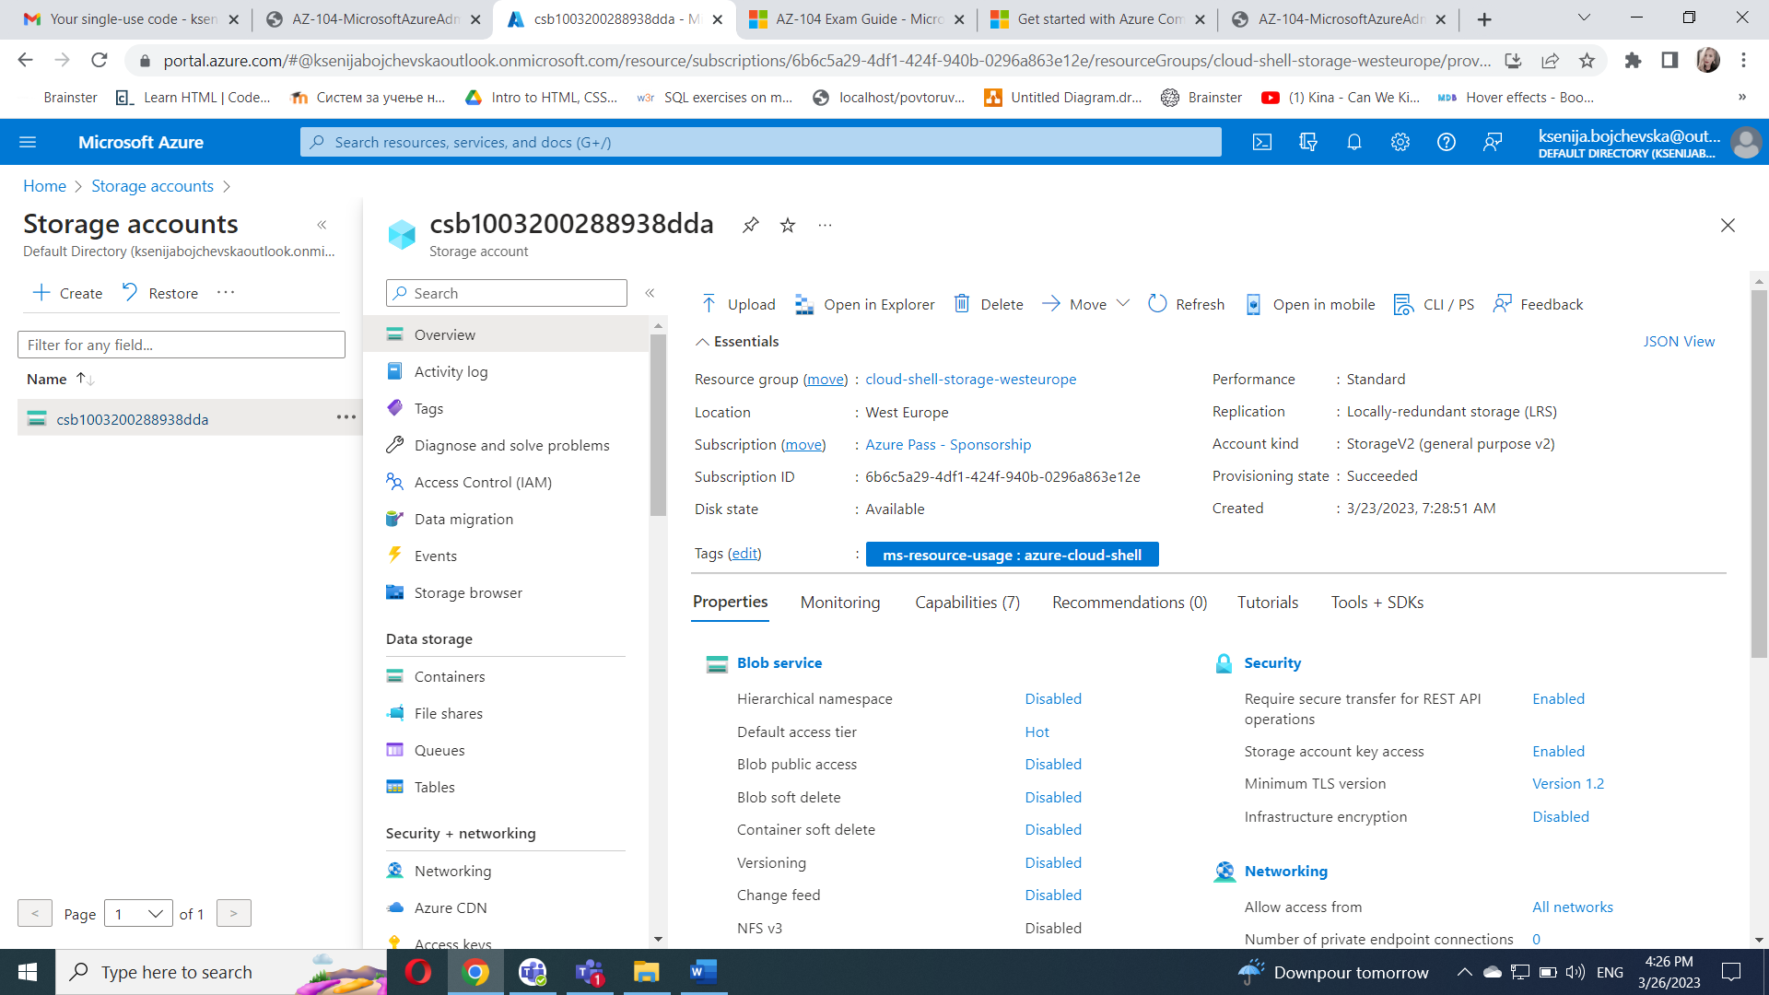

On the storage account blade, click the link representing the name of the resource group containing the storage account.

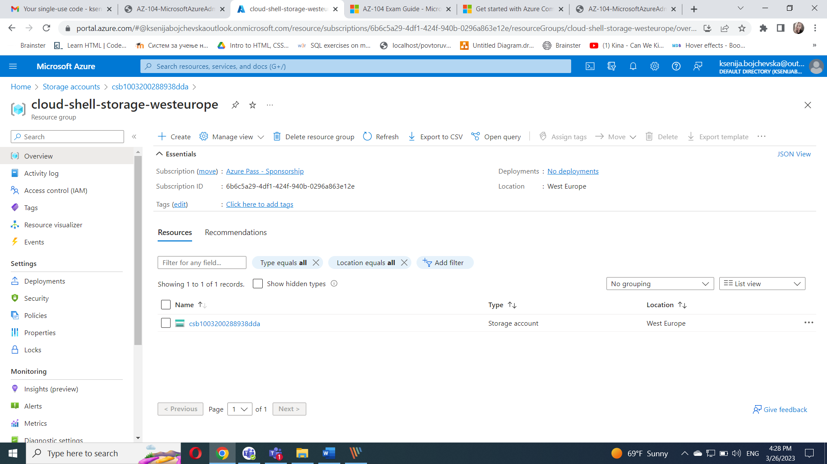

On the resource group blade, click **Tags** in the left menu and create a new tag.

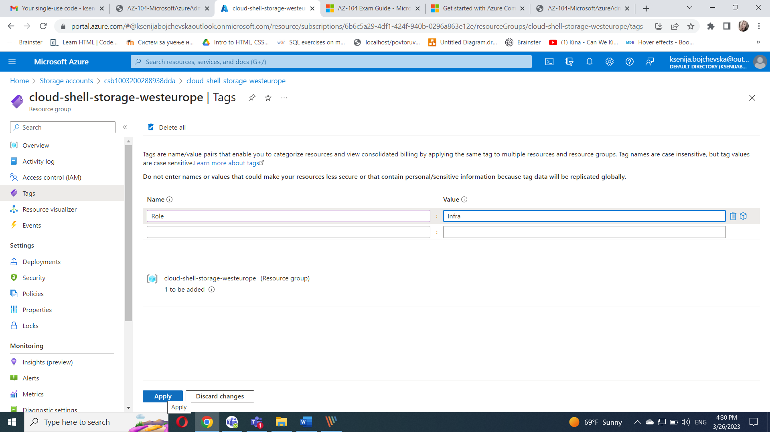

Click **Apply** and close the tag edition window to navigate back to the storage account blade. click on the ellipsis on the storage account and select **Edit tags** to note that the new tag was not automatically assigned to the storage account.

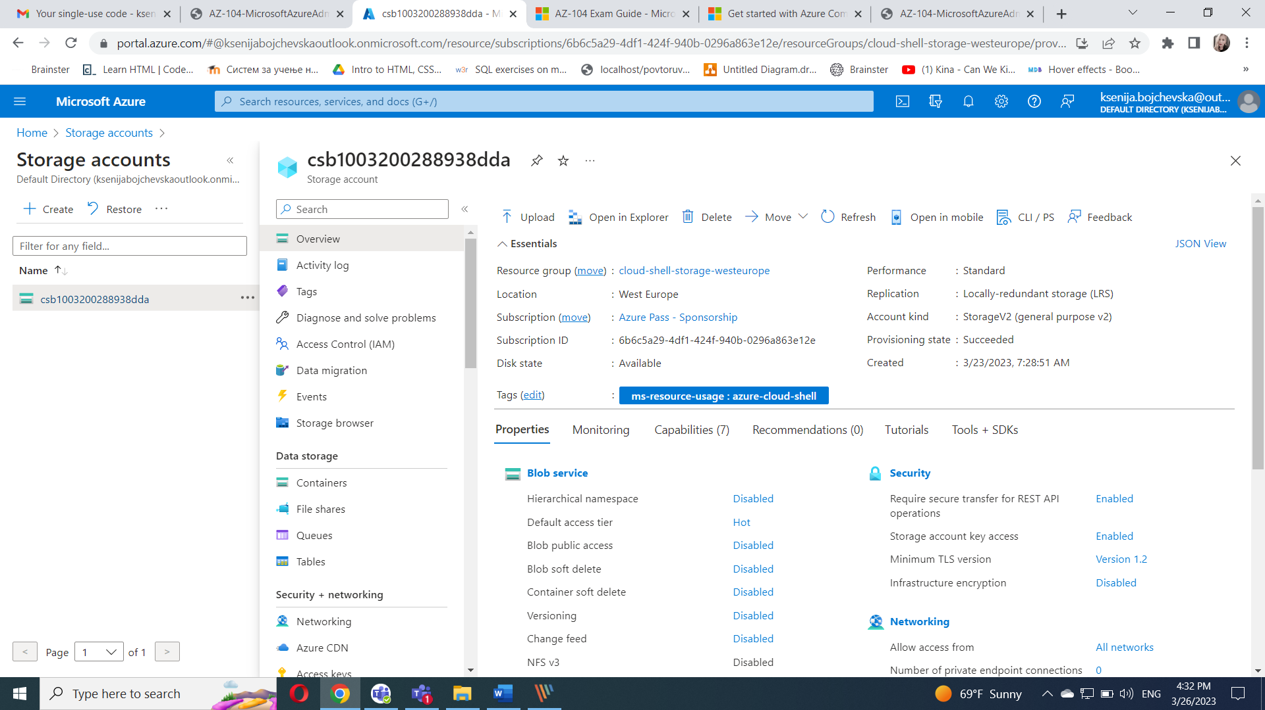

#### Task 2: Enforce tagging via an Azure policy

In the Azure portal, search for and select **Policy**.In the **Authoring** section, click **Definitions**.Click **Tags** entry (and de-selecting all other entries) in the **Category** drop-down list.

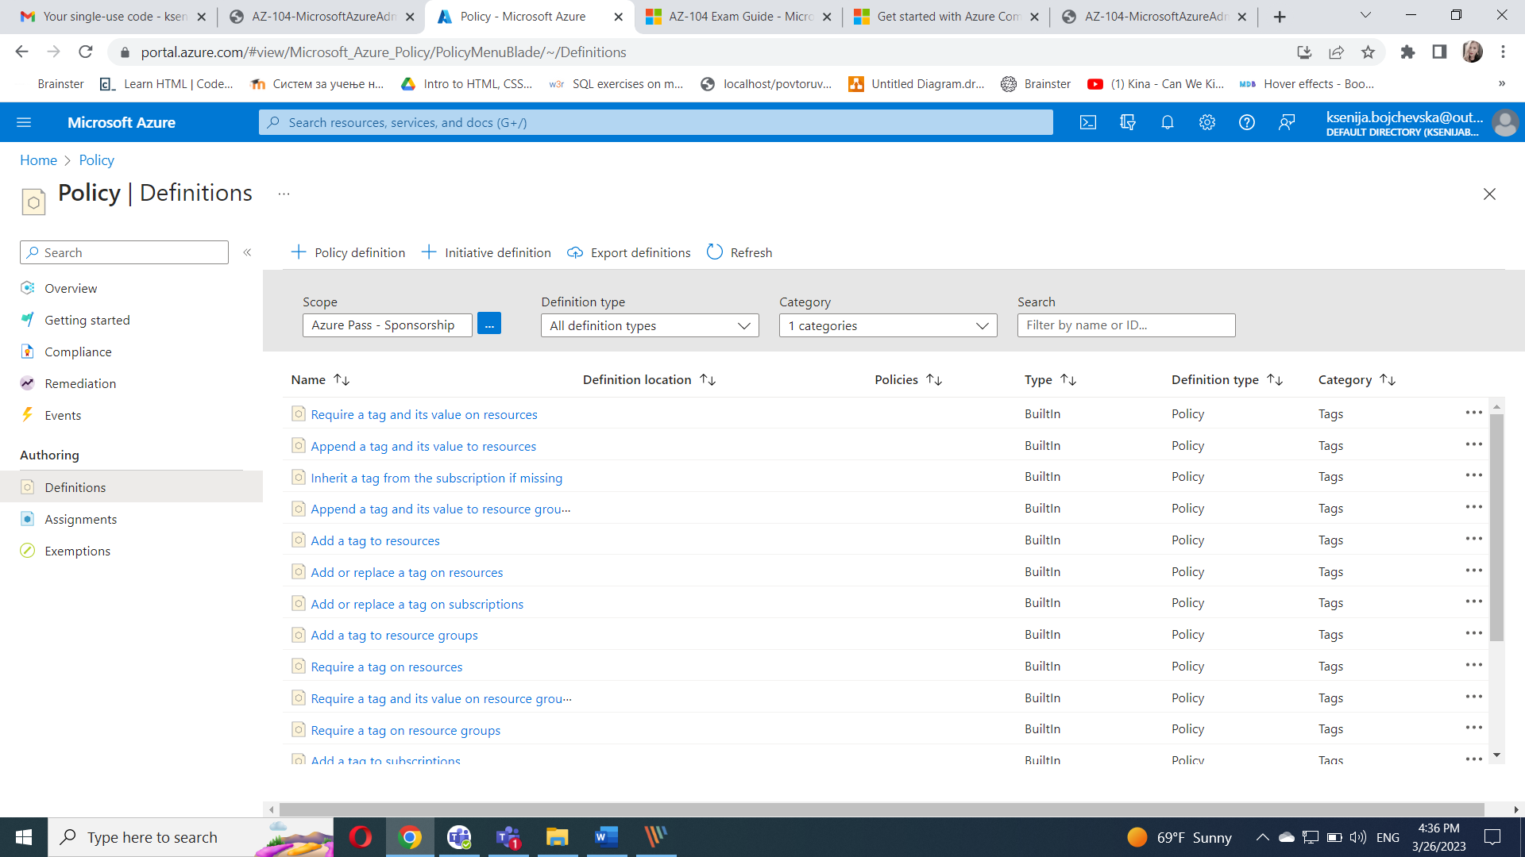

Click the entry representing the **Require a tag and its value on resources** built-in policy and review its definition.On the **Require a tag and its value on resources** built-in policy definition blade, click **Assign**. Specify the **Scope** by clicking the ellipsis button and selecting the following values:

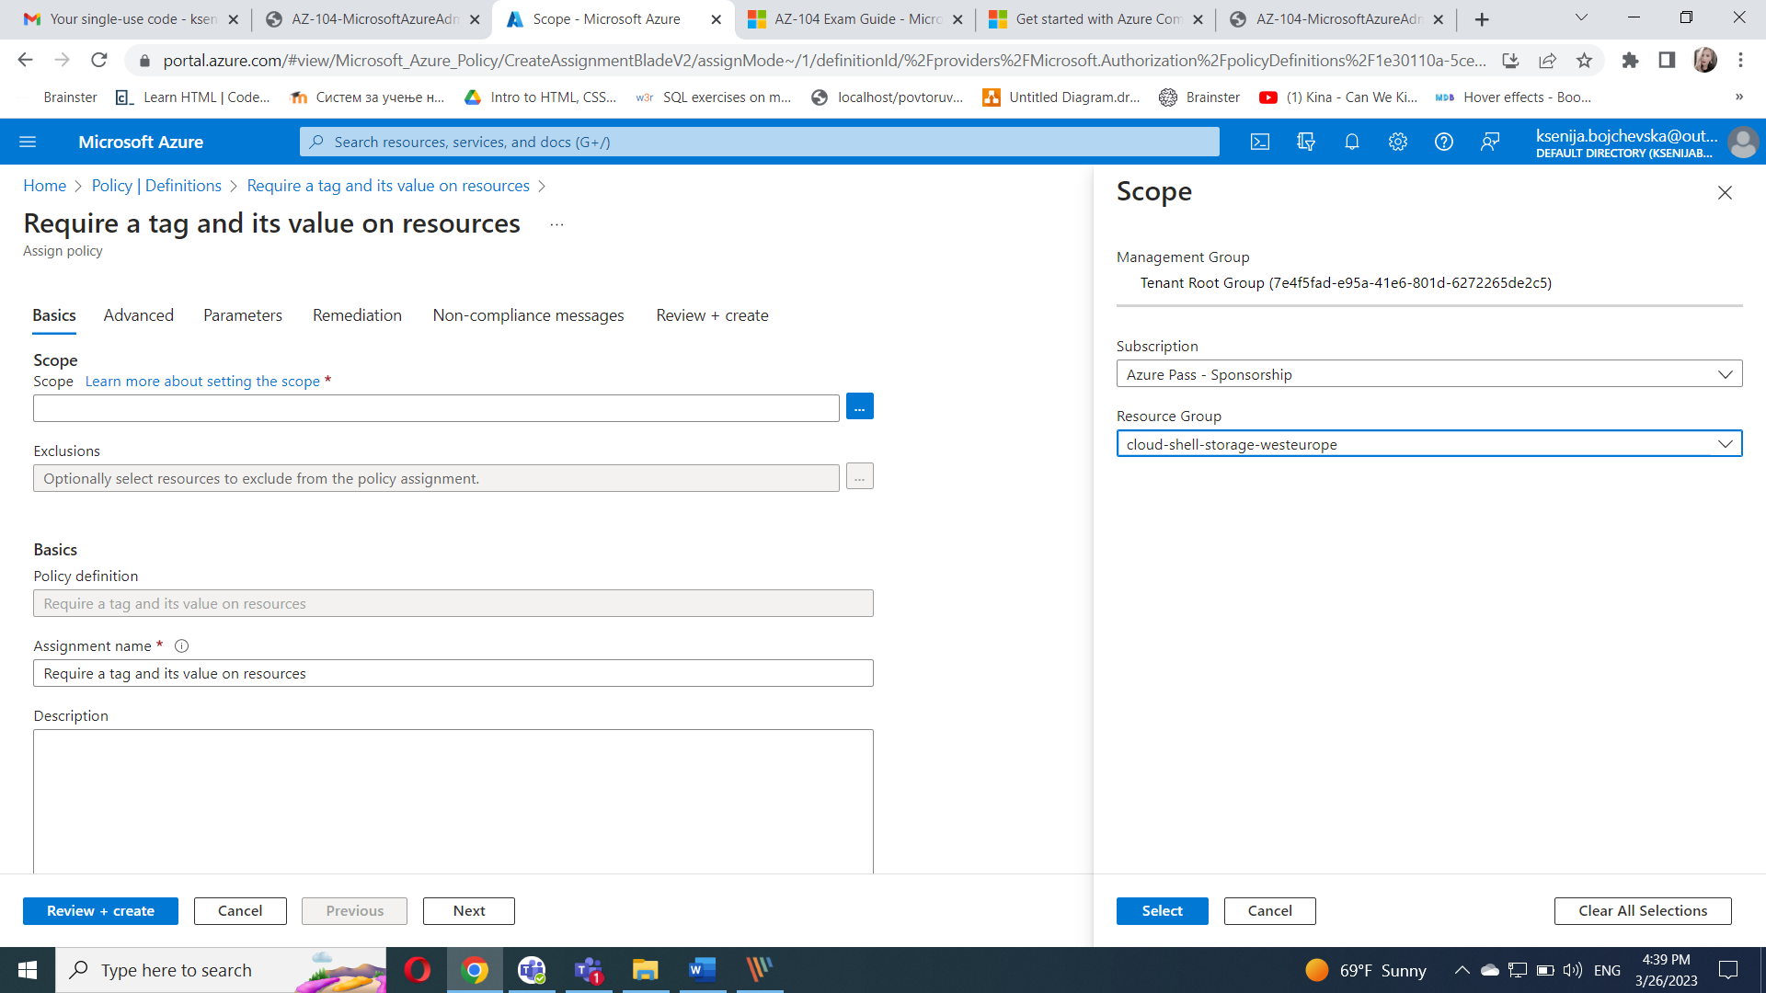

Configure the **Basics** properties of the assignment by specifying the following settings (leave others with their defaults):

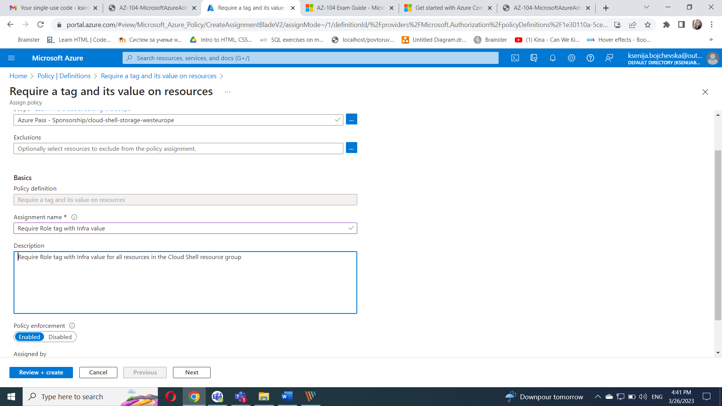

Click **Next** twice and set **Parameters** to the following values:

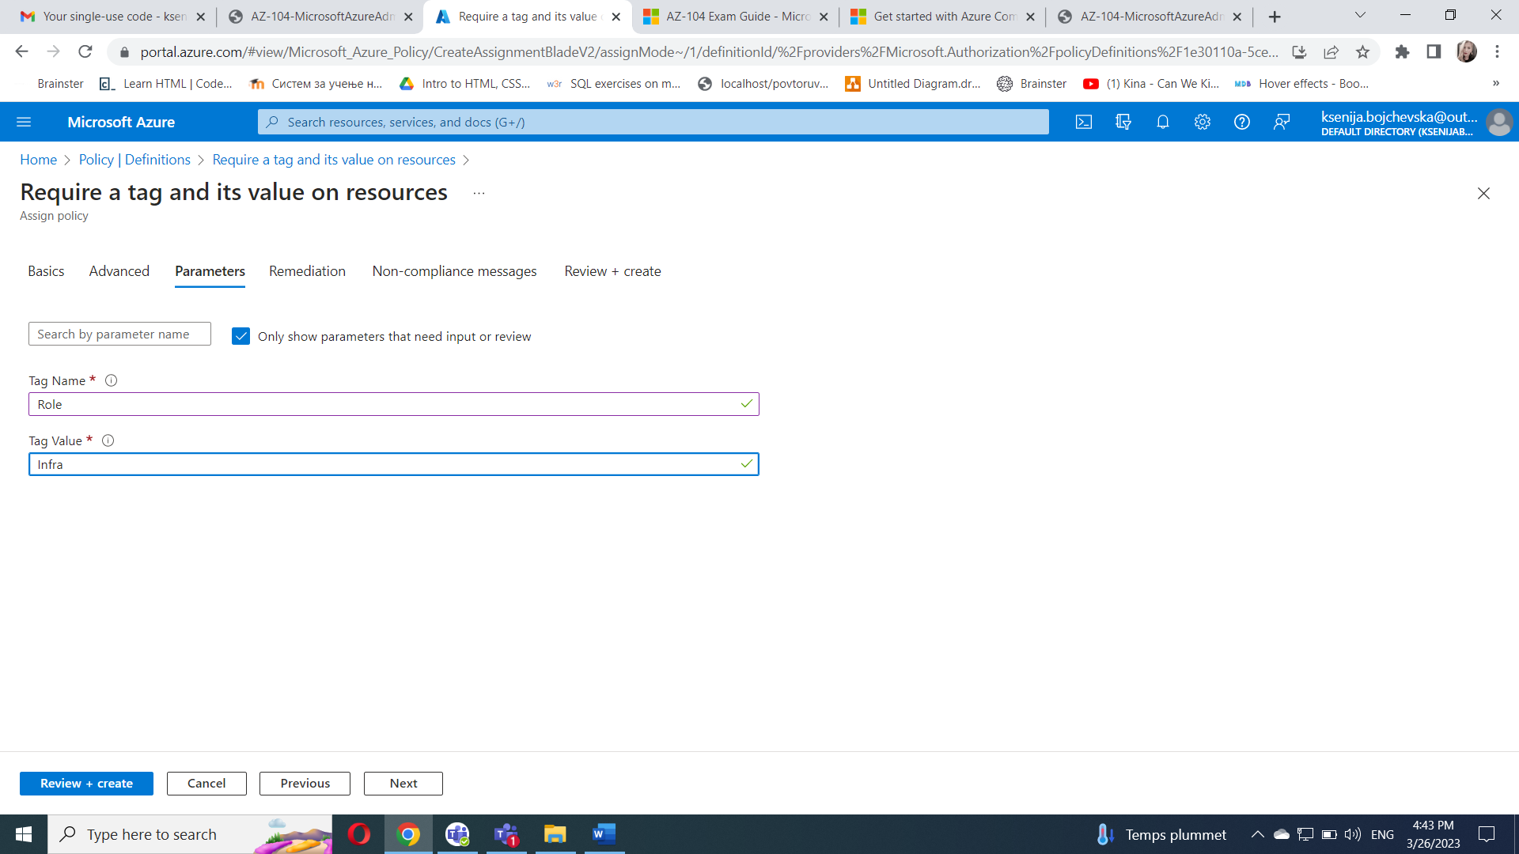

Click **Next** and review the **Remediation** tab. Leave the **Create a Managed Identity** checkbox unchecked. Click **Review + Create** and then click **Create**.

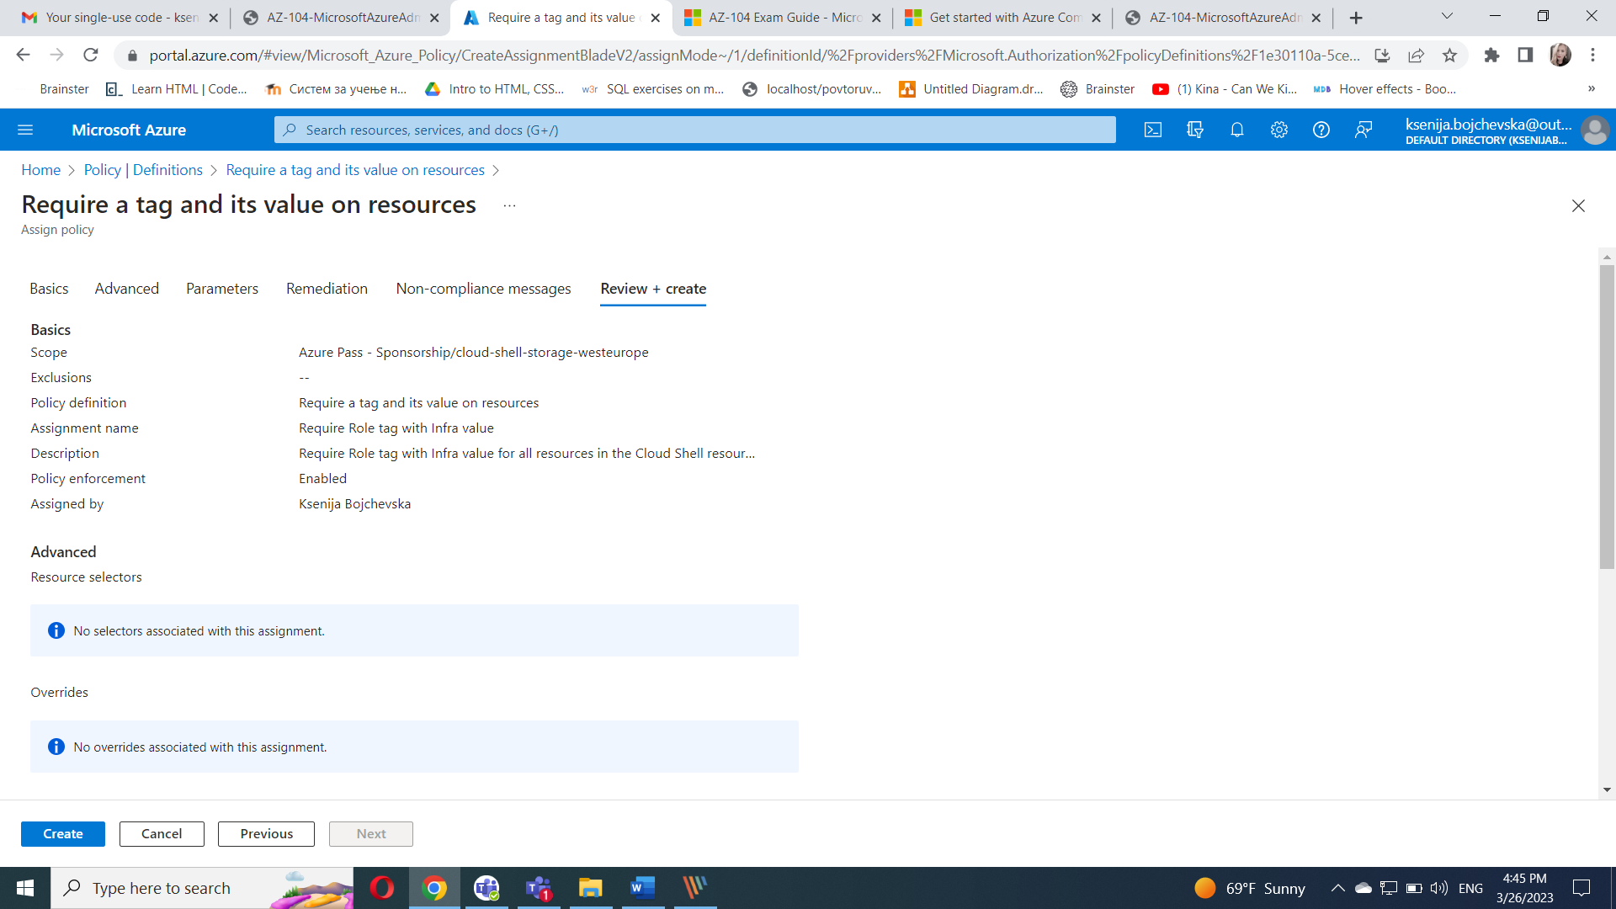

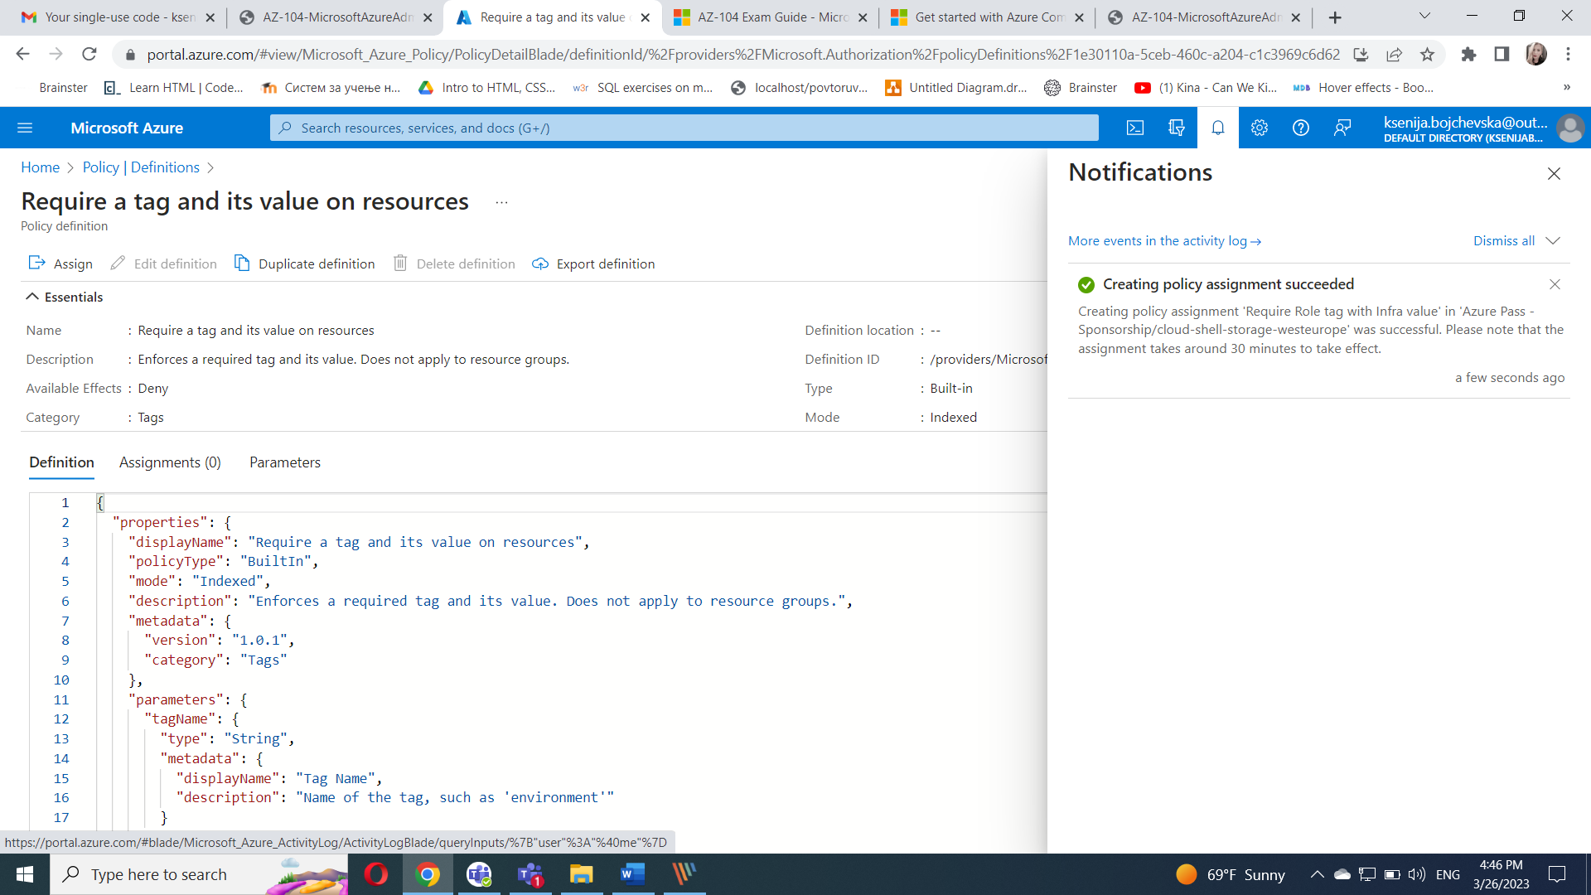

Navigate back to the blade of the resource group hosting the storage account used for the Cloud Shell home drive, which you identified in the previous task.

On the resource group blade, click **+ Create** and then search for **Storage Account**, and click **+ Create**.On the **Basics** tab of the **Create storage account** blade, verify that you are using the Resource Group that the Policy was applied to and specify the following settings (leave others with their defaults), click **Review** and then click **Create**:

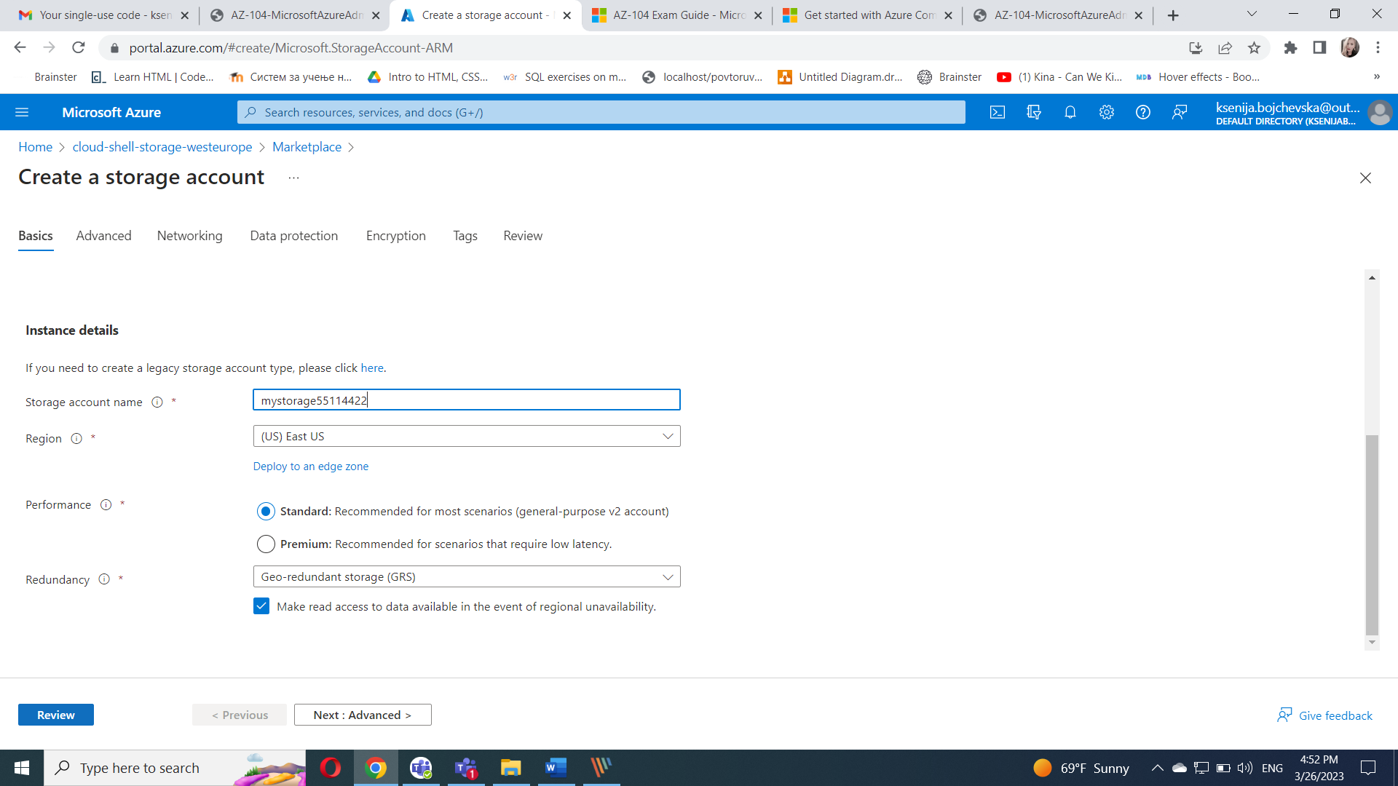

Once you create the deployment, you should see the **Deployment failed** message in the **Notifications** list of the portal. From the **Notifications** list, navigate to the deployment overview and click the **Deployment failed. Click here for details** message to identify the reason for the failure.

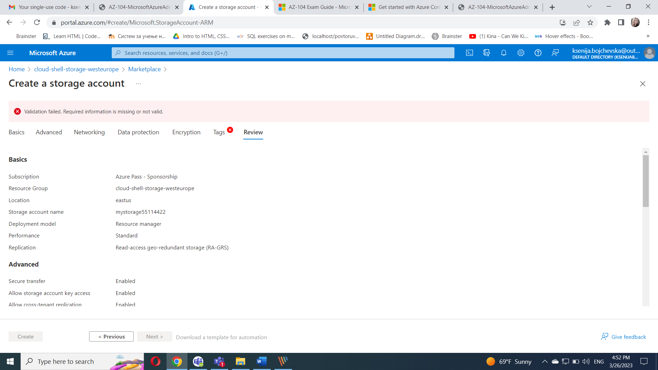

#### Task 3: Apply tagging via an Azure policy

In the Azure portal, search for and select **Policy**.In the **Authoring** section, click **Assignments**.

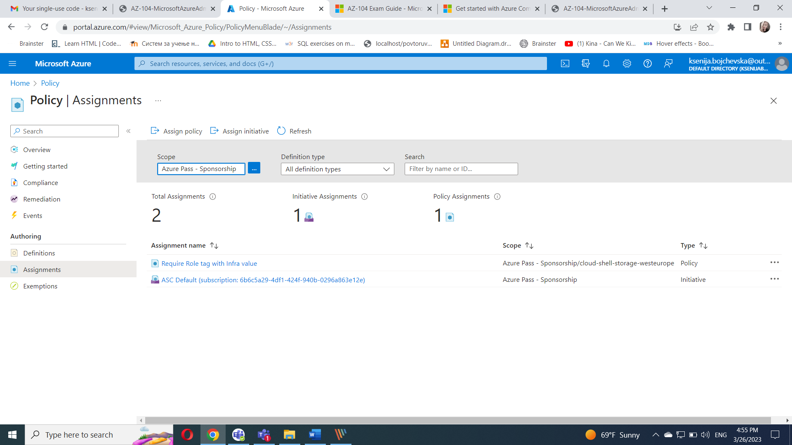

In the list of assignments, click the ellipsis icon in the row representing the **Require Role tag with Infra value** policy assignment and use the **Delete assignment** menu item to delete the assignment.

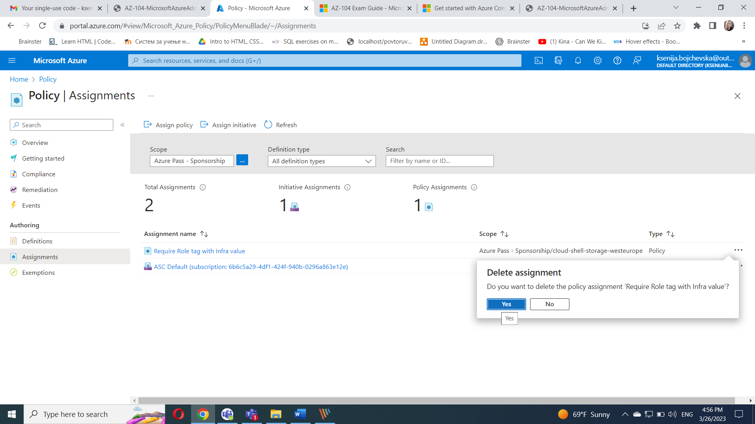

Click **Assign policy** and specify the **Scope** by clicking the ellipsis button and selecting the following values:

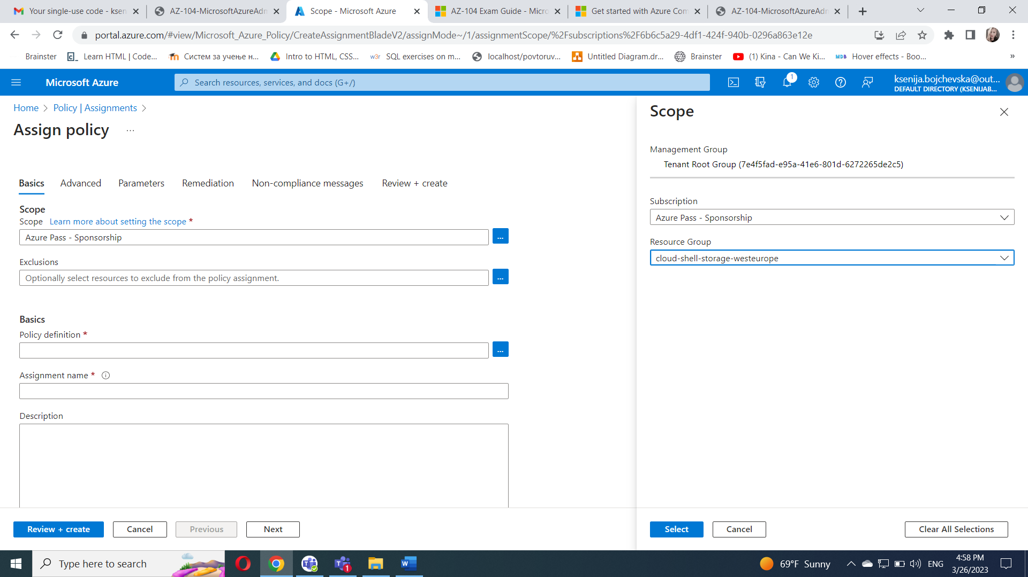

To specify the **Policy definition**, click the ellipsis button and then search for and select **Inherit a tag from the resource group if missing**.

Configure the remaining **Basics** properties of the assignment by specifying the following settings (leave others with their defaults):

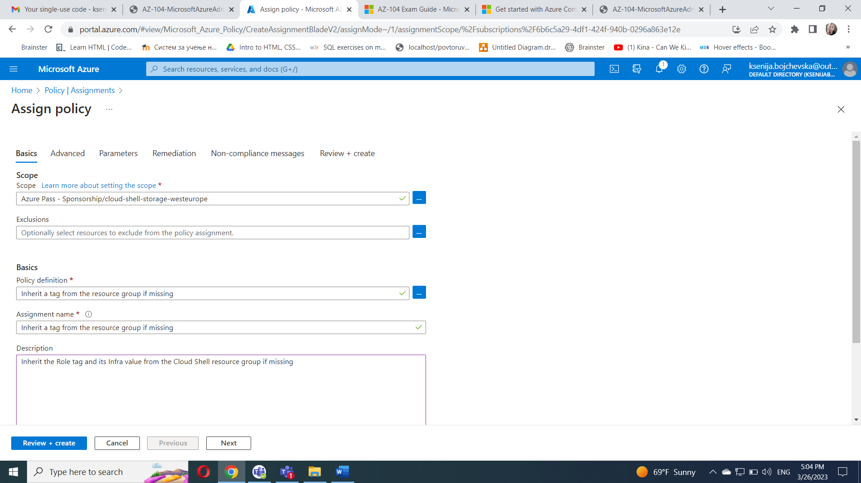

Click **Next** twice and set **Parameters** to the following values:

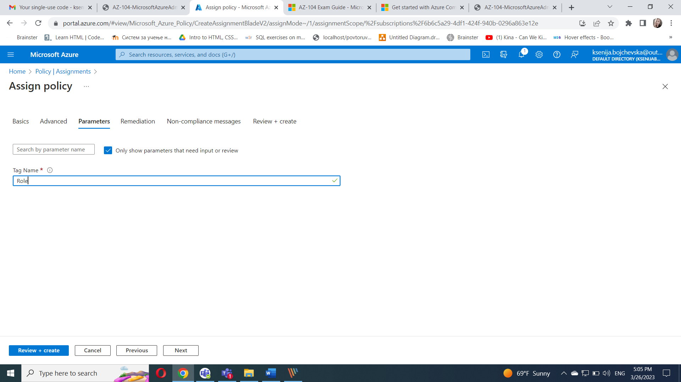

Click **Next** and, on the **Remediation** tab, configure the following settings (leave others with their defaults):

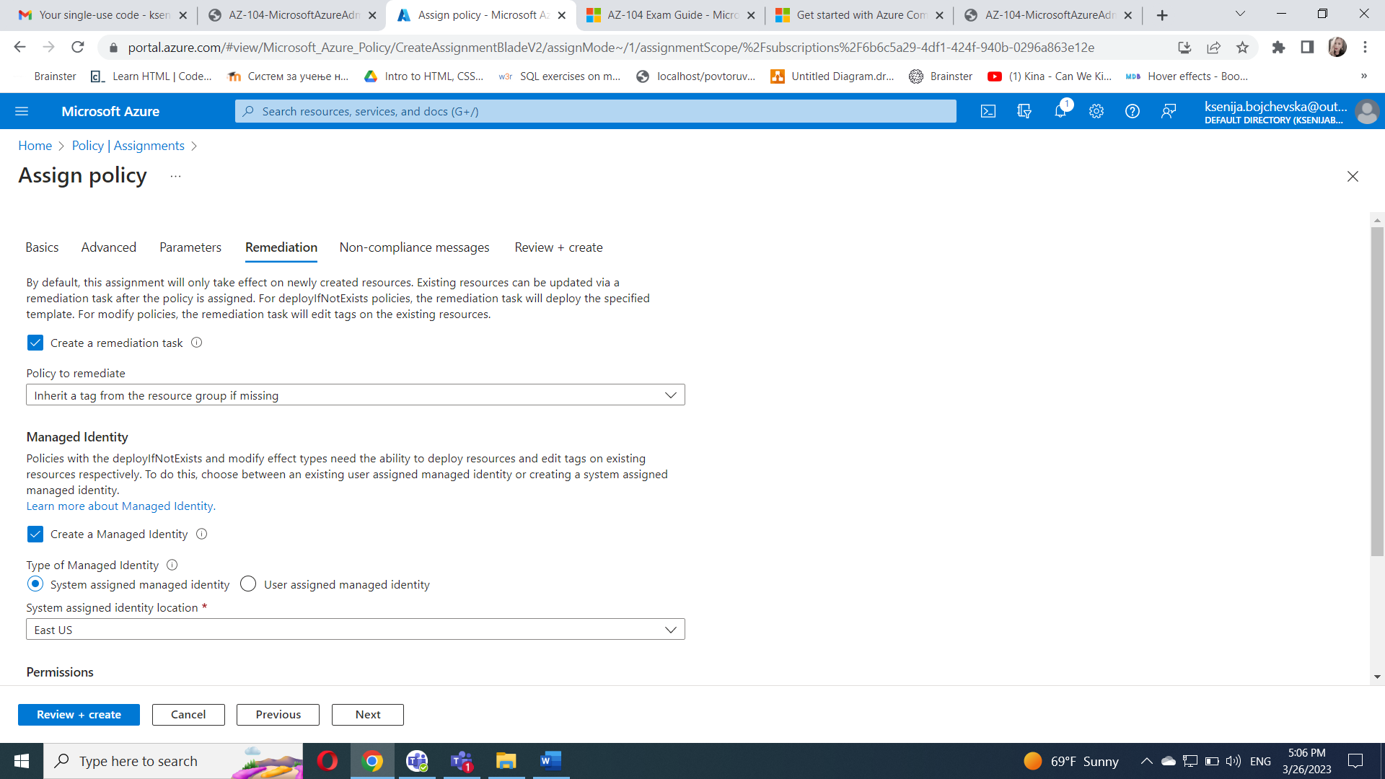

Click **Review + Create** and then click **Create**.

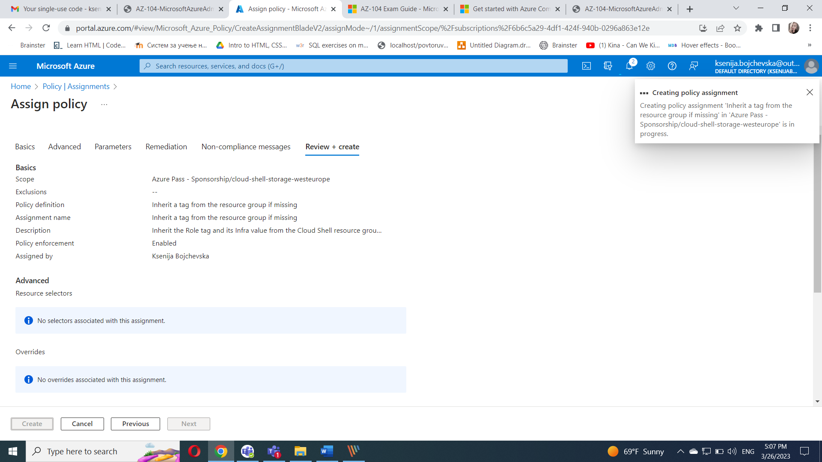

Navigate back to the blade of the resource group hosting the storage account used for the Cloud Shell home drive, which you identified in the first task.On the resource group blade, click **+ Create** and then search for **Storage Account**, and click **+ Create**.

On the **Basics** tab of the **Create storage account** blade, verify that you are using the Resource Group that the Policy was applied to and specify the following settings (leave others with their defaults) and click **Review**:

